

KARNATAKA STATE COUNCIL FOR SCIENCE AND TECHNOLOGY
Indian Institute of Science campus, Bengaluru – 560 012
Telephone: 080 – 23341652, 23348849 || Email: spp@kscst.org.in
Website: www.kscst.org.in/spp.html or https://kscst.karnataka.gov.in/en
FORMAT FOR STUDENT PROJECT PROPOSAL FOR THE
50th SERIES OF STUDENT PROJECT PROGRAMME 2026 – 2027
(Celebrating the Golden Jubilee of KSCST’s flagship Student Project Programme)

CALL FOR PROJECT PROPOSALS FROM FINAL-YEAR STUDENTS
B.E. | B.Arch. | M.Tech. | M.Sc. | M.Tech. / M.Sc. (Agriculture) | MBA | MCA

PART–A: GENERAL INFORMATION
(Please fill in all details in UPPERCASE LETTERS, except for the Email ID.)
Project Title: SELF-CALIBRATING MULTI-MODAL EDGE AI NODE FOR INDUSTRIAL MACHINE ANOMALY DETECTION

Keywords (5–8): INDUSTRIAL ANOMALY DETECTION, TINYML, SENSOR FUSION, PREDICTIVE MAINTENANCE, EDGE AI, AUTOENCODER, EMBEDDED SYSTEMS, INDUSTRIAL IOT
Broad Theme:
- Theme No.: 2
- Theme Name: WATER RESOURCES, ENVIRONMENT AND CLIMATE RESILIENCE
3. Sub-theme / Focus Area: ENVIRONMENTAL IMPACT ASSESSMENT AND NATURAL RESOURCE MANAGEMENT (FOCUSSING SPECIFICALLY ON ENVIRONMENTAL IMPACT ASSESSMENT)
Institution Details:
- Name of Institution: DAYANANDA SAGAR UNIVERSITY
- Course Name: B.TECH
- Department Name: COMPUTER SCIENCE ENGINEERING
- Affiliated University: NA
5. District of Your Institution: Bengaluru South Dt
6. Complete Postal Address of the Institution with Pin code: DAYANANDA SAGAR UNIVERSITY, SCHOOL OF ENGINEERING, Devarakaggalahalli, Harohalli, Kanakapura Road, Bengaluru South Dt. – 562 112.
Project Guide Details:
- Project Guide Name: Dr. MEENAKSHI MALHOTRA
- Project Guide Designation: ASSOCIATE PROFESSOR
- Project Guide Department: COMPUTER SCIENCE and ENGINEERING
- Project Guide Email id: meenakshi.malhotra-cse@dsu.edu.in
- Project Guide Mobile Number: +91 9880858358
Student Team Details:

Sl. No. | Insert Passport-size Photograph | Name of the Student  (BLOCK LETTERS) | USN / Registration No. | Degree & Branch & Semester | Category as per College Records (SC/ST/  OBC/  General) | Mobile No. | Email Id
1. | 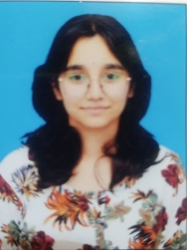 | Ms. NIKITHA D  (TEAM LEADER) | ENG23CS0384 | Degree: BTECH  Branch: CSE  Semester: 7 | OBC | +91 8050120456 | eng23cs0384@dsu.edu.in
2. | 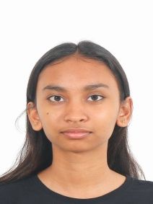 | Ms. MONALISA | ENG23CS0368 | Degree: BTECH  Branch: CSE  Semester: 7 | GENERAL | +91 9444487072 | eng23cs0368@dsu.edu.in
3. | 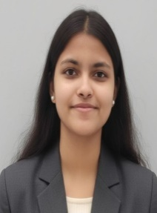 | Ms.RAJIKA SAHA | ENG23CS0415 | Degree: BTECH  Branch: CSE  Semester: 7 | GENERAL | +91 9748634594 | eng23cs0415@dsu.edu.in
4. |  | Mr. SUNAND P CHOWDARY | ENG23CS0387 | Degree: BTECH  Branch: CSE  Semester: 7 | GENERAL | +91 9148239819 | eng23cs0387@dsu.edu.in

SPP Coordinator Details:
- SPP Coordinator Name: Mr. SRIPAD KULKARNI S
- SPP Coordinator Designation: ASSISSTANT PROFESSOR
- SPP Coordinator Email: sripad-ae@dsu.edu.in
- SPP Coordinator Mobile Number: +91 7406907182

PART - B: PROJECT DESCRIPTION
Background and Need of the Project:
INDUSTRIAL MACHINES SUCH AS MOTORS, PUMPS AND FANS ARE ESSENTIAL TO MANUFACTURING OPERATIONS. UNEXPECTED MACHINE FAILURES CAN INTERRUPT PRODUCTION, INCREASE MAINTENANCE COSTS AND AFFECT PRODUCTIVITY and pose environmental issues. EARLY DETECTION OF ABNORMAL OPERATING CONDITIONS CAN HELP INDUSTRIES IDENTIFY POTENTIAL FAULTS BEFORE THEY LEAD TO MAJOR FAILURES.

EXISTING MACHINE-CONDITION MONITORING APPROACHES USE VIBRATION ANALYSIS, ACOUSTIC MONITORING OR A COMBINATION OF SENSORS. HOWEVER, CONVENTIONAL INDUSTRIAL MONITORING SYSTEMS CAN BE EXPENSIVE and REQUIRE SUBSTANTIAL COMPUTING RESOURCES, CONTINUOUS CONNECTIVITY OR SPECIALIST INTERPRETATION. THESE LIMITATIONS CAN MAKE ADOPTION DIFFICULT FOR SMALL AND MEDIUM-SIZED ENTERPRISES (MSMES).

THE PROPOSED PROJECT DEVELOPS A **Environment friendly SELF-CALIBRATING, MULTIMODAL EDGE AI NODE FOR INDUSTRIAL MACHINE ANOMALY DETECTION**. IT COMBINES AN INMP441 MICROPHONE AND AN MPU6050 ACCELEROMETER/GYROSCOPE WITH AN ESP32-S3 MICROCONTROLLER TO CAPTURE ACOUSTIC AND VIBRATION SIGNALS. A LIGHTWEIGHT MACHINE-LEARNING MODEL WILL LEARN PATTERNS FROM HEALTHY OPERATING CONDITIONS AND IDENTIFY DEVIATIONS LOCALLY ON THE DEVICE. A SELF-CALIBRATION MECHANISM WILL ESTABLISH A MACHINE-SPECIFIC BASELINE AND ADAPT THE ANOMALY THRESHOLD TO ITS OBSERVED BEHAVIOUR.

THE NEED FOR THIS PROJECT IS TO EXPLORE AN AFFORDABLE, COMPACT AND OFFLINE-CAPABLE MONITORING SOLUTION THAT REDUCES DEPENDENCE ON CLOUD PROCESSING AND SUPPORTS TIMELY IDENTIFICATION OF ABNORMAL MACHINE BEHAVIOUR. THE SYSTEM WILL BE EVALUATED USING AVAILABLE MACHINE-CONDITION DATASETS AND PHYSICAL HARDWARE TESTING.

THE INTENDED BENEFICIARIES ARE MSMES, SMALL MANUFACTURING UNITS, MAINTENANCE TECHNICIANS AND MACHINE OPERATORS WHO NEED ACCESSIBLE CONDITION-MONITORING TOOLS. THE PROJECT AIMS TO SUPPORT PREVENTIVE MAINTENANCE AND REDUCE AVOIDABLE DOWNTIME--- as well additional heat or sound from the machines. THESE BENEFITS WILL NEED TO BE ASSESSED THROUGH TESTING AND VALIDATION.
Review of Existing Work:
EXISTING MACHINE-ANOMALY DETECTION APPROACHES USE ACOUSTIC MONITORING, VIBRATION ANALYSIS AND MACHINE-LEARNING MODELS TO IDENTIFY ABNORMAL OPERATING CONDITIONS. PUBLIC DATASETS SUCH AS THE MIMII INDUSTRIAL SOUND DATASET SUPPORT RESEARCH ON DETECTING ANOMALIES IN INDUSTRIAL MACHINE SOUNDS. AUTOENCODERS ARE A SUITABLE APPROACH FOR UNSUPERVISED ANOMALY DETECTION BECAUSE THEY CAN LEARN NORMAL OPERATING PATTERNS AND FLAG SAMPLES WITH HIGH RECONSTRUCTION ERROR.

COMMERCIAL CONDITION-MONITORING SYSTEMS OFFER MACHINE-HEALTH MONITORING AND PREDICTIVE-MAINTENANCE CAPABILITIES, BUT THE PROJECT REVIEW IDENTIFIES COST, CONNECTIVITY AND DEPLOYMENT CONSTRAINTS AS CONCERNS FOR SMALLER MANUFACTURING UNITS. EDGE AI AND TINYML PROVIDE AN ALTERNATIVE BY ENABLING INFERENCE ON RESOURCE-CONSTRAINED EMBEDDED DEVICES. THE PROPOSED IMPLEMENTATION USES AN ESP32-S3, AN INMP441 MICROPHONE, AN MPU6050 MOTION SENSOR AND TENSORFLOW LITE FOR MICROCONTROLLERS.

THE REVIEWED WORK IDENTIFIES THREE MAIN RESEARCH GAPS: LIMITED ROBUSTNESS OF AUDIO-ONLY SYSTEMS IN NOISY INDUSTRIAL ENVIRONMENTS, DIFFICULTY ADAPTING FIXED MODELS TO DIFFERENT MACHINES WITHOUT RETRAINING, AND INSUFFICIENT PHYSICAL HARDWARE VALIDATION IN SOME EXISTING APPROACHES. THE PROPOSED PROJECT ADDRESSES THESE GAPS THROUGH ACOUSTIC–VIBRATION SENSOR FUSION, MACHINE-SPECIFIC ON-DEVICE CALIBRATION AND VALIDATION ON A PHYSICAL MOTOR TEST RIG.

A COMPREHENSIVE REVIEW OF SPECIFIC COMMERCIAL PRODUCT MODELS, INDIVIDUAL RESEARCH-PAPER RESULTS AND RELEVANT PATENTS SHOULD BE COMPLETED BEFORE SUBMISSION IF THESE DETAILS ARE REQUIRED BY THE EVALUATORS.
Problem Statement:

SMALL AND MEDIUM-SIZED MANUFACTURING UNITS NEED AN AFFORDABLE AND RELIABLE WAY TO DETECT EARLY SIGNS OF ABNORMAL OPERATION IN INDUSTRIAL MACHINES SUCH AS MOTORS, FANS AND PUMPS. EXISTING MONITORING APPROACHES MAY INVOLVE EXPENSIVE EQUIPMENT, CLOUD CONNECTIVITY OR MODELS THAT DO NOT ADAPT EASILY TO DIFFERENT MACHINES AND NOISY OPERATING ENVIRONMENTS.

THE PROBLEM ADDRESSED BY THIS PROJECT IS THE DEVELOPMENT OF A LOW-COST, STANDALONE EDGE AI SYSTEM THAT COMBINES ACOUSTIC AND VIBRATION SIGNALS TO DETECT MACHINE ANOMALIES LOCALLY, WITHOUT CONTINUOUS INTERNET CONNECTIVITY. THE SYSTEM WILL USE A LIGHTWEIGHT AUTOENCODER TRAINED ON HEALTHY OPERATING DATA AND AN ON-DEVICE CALIBRATION MECHANISM TO ESTABLISH MACHINE-SPECIFIC BASELINES AND ANOMALY THRESHOLDS. ITS DETECTION PERFORMANCE, COMPUTATIONAL REQUIREMENTS AND PRACTICAL OPERATION WILL BE EVALUATED THROUGH DATASET-BASED TESTING AND PHYSICAL HARDWARE VALIDATION, WITH A TARGET ROC-AUC GREATER THAN 0.90.
Objectives:
1.

- TO IMPLEMENT ON-DEVICE STATISTICAL CALIBRATION USING THE MEAN AND STANDARD DEVIATION OF RECONSTRUCTION ERRORS, WITH A DYNAMIC ANOMALY THRESHOLD OF Τ = Μ_ERROR + 3Σ_ERROR, ENABLING MACHINE-SPECIFIC ADAPTATION WITHOUT RETRAINING THE MODEL.TO IMPLEMENT MULTIMODAL SIGNAL PROCESSING THAT COMBINES ACOUSTIC FEATURES EXTRACTED USING A 1024-POINT FFT AND 64-BAND LOG-MEL FILTERBANK WITH THREE-AXIS VIBRATION RMS FEATURES, FORMING A 67-DIMENSIONAL FEATURE VECTOR.
- Env related

3. TO DESIGN AND DEVELOP A LOW-COST INDUSTRIAL MACHINE ANOMALY DETECTION PROTOTYPE USING AN ESP32-S3 MICROCONTROLLER, INMP441 MICROPHONE AND MPU6050 VIBRATION SENSOR, TARGETING A HARDWARE COST OF APPROXIMATELY ₹1,500 PER DEVICE. TO TRAIN AN UNSUPERVISED DENSE AUTOENCODER USING HEALTHY MACHINE DATA AND DEPLOY THE QUANTIZED MODEL ON THE ESP32-S3 USING TENSORFLOW LITE FOR MICROCONTROLLERS.

4.

5. TO EVALUATE THE SYSTEM USING THE MIMII INDUSTRIAL SOUND DATASET AND CWRU BEARING DATASET, TARGETING ROC-AUC GREATER THAN 0.90 AND ASSESSING PRECISION, RECALL, F1-SCORE AND CONFUSION MATRIX.

6. TO INTEGRATE THE SENSORS, MICROCONTROLLER AND LED INDICATORS INTO A STANDALONE PROTOTYPE AND VALIDATE ITS ANOMALY-DETECTION PERFORMANCE, INFERENCE OPERATION AND RESOURCE REQUIREMENTS ON A PHYSICAL MOTOR TEST RIG UNDER DIFFERENT OPERATING AND NOISE CONDITIONS.
Innovation / Novelty:
THE PROPOSED SYSTEM COMBINES ACOUSTIC AND VIBRATION SENSING WITH LIGHTWEIGHT EDGE AI TO DETECT INDUSTRIAL MACHINE ANOMALIES ON A LOW-COST ESP32-S3 MICROCONTROLLER. UNLIKE AUDIO-ONLY OR VIBRATION-ONLY APPROACHES, IT USES COMPLEMENTARY SENSING CHANNELS TO IMPROVE THE RELIABILITY OF ANOMALY DETECTION IN NOISY INDUSTRIAL ENVIRONMENTS.

THE KEY INNOVATION IS AN ON-DEVICE STATISTICAL CALIBRATION MECHANISM THAT ESTABLISHES A MACHINE-SPECIFIC HEALTHY BASELINE AND DYNAMICALLY SETS THE ANOMALY THRESHOLD USING RECONSTRUCTION-ERROR STATISTICS. THIS AIMS TO REDUCE DEPENDENCE ON MACHINE-SPECIFIC MODEL RETRAINING WHEN DEPLOYING THE SYSTEM ON DIFFERENT MACHINES.

THE PROJECT ALSO TARGETS FULLY OFFLINE INFERENCE WITHOUT CONTINUOUS CLOUD CONNECTIVITY, USING A QUANTIZED DENSE AUTOENCODER AND EMBEDDED SIGNAL PROCESSING. ITS DISTINGUISHING FEATURE IS THE PLANNED INTEGRATION OF MULTIMODAL SENSING, SELF-CALIBRATION AND PHYSICAL HARDWARE VALIDATION WITHIN AN AFFORDABLE EMBEDDED PLATFORM. THE NOVELTY WILL BE EVALUATED AGAINST THE EXISTING APPROACHES REVIEWED IN THE PHASE-I PRESENTATION, PARTICULARLY THEIR LIMITATIONS IN SENSOR FUSION, CROSS-MACHINE ADAPTATION AND LOW-COST MICROCONTROLLER DEPLOYMENT.
Proposed Methodology:
1. OVERALL METHODOLOGY

THE PROJECT WILL FOLLOW FIVE PHASES: MODEL DEVELOPMENT, MODEL COMPRESSION AND DEPLOYMENT, FIRMWARE AND DIGITAL SIGNAL PROCESSING INTEGRATION, ON-DEVICE CALIBRATION, AND PHYSICAL HARDWARE VALIDATION.

2. SYSTEM ARCHITECTURE AND WORKFLOW

INMP441 MICROPHONE + MPU6050 ACCELEROMETER/GYROSCOPE → ESP32-S3 DATA ACQUISITION → AUDIO FEATURE EXTRACTION USING 1024-POINT FFT AND 64-BAND LOG-MEL FILTERBANK + THREE-AXIS VIBRATION RMS → 67-DIMENSIONAL FEATURE VECTOR → QUANTIZED DENSE AUTOENCODER → RECONSTRUCTION ERROR CALCULATION → DYNAMIC THRESHOLD COMPARISON → LED STATUS (NORMAL/ANOMALY).

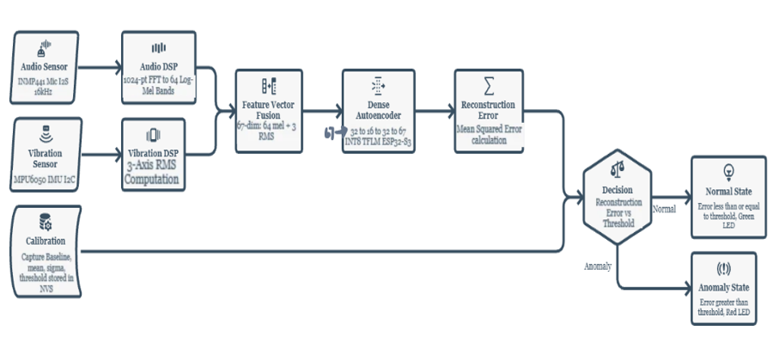

3. MODEL DEVELOPMENT

THE MIMII INDUSTRIAL SOUND DATASET (what is the datatype of audio files) is USED AS THE PRIMARY ACOUSTIC BENCHMARK. HEALTHY SAMPLES are USED TO TRAIN AN UNSUPERVISED DENSE AUTOENCODER, WHILE HELD-OUT HEALTHY AND ANOMALOUS SAMPLES WILL BE USED FOR EVALUATION. THE MODEL ARCHITECTURE IS INPUT (67) → DENSE (32, RELU) → DENSE (16, RELU) → DENSE (16, RELU) → DENSE (32, RELU) → OUTPUT (67, LINEAR). MEAN SQUARED RECONSTRUCTION ERROR WILL SERVE AS THE ANOMALY SCORE. THE CWRU BEARING DATASET WILL SUPPORT VIBRATION-BASED BENCHMARKING.

4. MODEL COMPRESSION AND EMBEDDED DEPLOYMENT

THE TRAINED MODEL WILL UNDERGO INT8 POST-TRAINING QUANTIZATION, WITH QUANTIZATION-AWARE TRAINING CONSIDERED IF REQUIRED. IT WILL THEN BE CONVERTED TO TENSORFLOW LITE FOR MICROCONTROLLERS FORMAT AND INTEGRATED INTO ESP32-S3 FIRMWARE USING THE TFLM C++ API. EMBEDDED INFERENCE WILL BE CHECKED AGAINST THE PYTHON REFERENCE MODEL.

5. FIRMWARE AND SENSOR INTEGRATION

THE FIRMWARE WILL IMPLEMENT I2S DMA-BASED AUDIO CAPTURE, FFT AND LOG-MEL FEATURE EXTRACTION USING THE ESP-DSP LIBRARY, AND VIBRATION-DATA ACQUISITION OVER I2C. THE EXTRACTED AUDIO AND VIBRATION FEATURES WILL BE FUSED INTO THE 67-DIMENSIONAL INPUT VECTOR FOR THE ON-DEVICE MODEL.

6. SELF-CALIBRATION AND ANOMALY DETECTION

DURING SETUP, THE DEVICE WILL CAPTURE HEALTHY OPERATING DATA AND CALCULATE THE BASELINE STATISTICS. THE ANOMALY THRESHOLD WILL BE DETERMINED USING Τ = Μ_ERROR + 3Σ_ERROR, WHERE Μ_ERROR AND Σ_ERROR REPRESENT THE MEAN AND STANDARD DEVIATION OF BASELINE RECONSTRUCTION ERRORS. CALIBRATION PARAMETERS WILL BE STORED IN ESP32 NON-VOLATILE STORAGE (NVS). SAMPLES EXCEEDING THE THRESHOLD WILL TRIGGER AN ANOMALY INDICATION THROUGH THE LED.

7. EXPERIMENTAL PLAN AND VALIDATION

THE SYSTEM WILL FIRST BE EVALUATED ON HELD-OUT DATASET SAMPLES USING ROC-AUC, PRECISION, RECALL, F1-SCORE AND A CONFUSION MATRIX. THE ASSEMBLED PROTOTYPE WILL THEN BE MOUNTED ON A PHYSICAL MOTOR TEST RIG AND EVALUATED UNDER DIFFERENT OPERATING CONDITIONS AND BACKGROUND NOISE. INFERENCE LATENCY, MEMORY USAGE AND POWER CONSUMPTION WILL ALSO BE PROFILED. THE TARGET IS ROC-AUC GREATER THAN 0.90; THIS IS A PLANNED TARGET, NOT A CONFIRMED RESULT.

8. SOFTWARE AND HARDWARE

HARDWARE: ESP32-S3-N8R8, INMP441 I2S MEMS MICROPHONE, MPU6050 SIX-AXIS ACCELEROMETER/GYROSCOPE, LED INDICATORS, AND AN INA219 CURRENT SENSOR OR USB POWER METER FOR POWER MEASUREMENT.

SOFTWARE: PYTHON 3.10+, PYTORCH/TENSORFLOW 2.X, KERAS, LIBROSA, SCIPY, NUMPY, SCIKIT-LEARN, TENSORFLOW LITE CONVERTER, TENSORFLOW LITE FOR MICROCONTROLLERS, ARDUINO IDE/ESP-IDF (C++), ESP-DSP AND ESP32 NVS/PREFERENCES STORAGE.

Expected Deliverables:
1. HARDWARE PROTOTYPE: A LOW-COST INDUSTRIAL MACHINE ANOMALY DETECTION DEVICE BUILT USING THE ESP32-S3, INMP441 MICROPHONE, MPU6050 VIBRATION SENSOR AND LED INDICATORS, TARGETING A COST OF APPROXIMATELY ₹1,500 PER DEVICE.

2. EMBEDDED SOFTWARE/FIRMWARE: C++ FIRMWARE FOR SENSOR ACQUISITION, SIGNAL PROCESSING, MULTIMODAL FEATURE EXTRACTION, ON-DEVICE INFERENCE AND LED-BASED ANOMALY ALERTS.

3. TRAINED MACHINE LEARNING MODEL: A LIGHTWEIGHT DENSE AUTOENCODER TRAINED ON HEALTHY MACHINE DATA, QUANTIZED TO INT8 AND DEPLOYED USING TENSORFLOW LITE FOR MICROCONTROLLERS.

4. SELF-CALIBRATION MODULE: AN ON-DEVICE CALIBRATION MECHANISM THAT CALCULATES BASELINE STATISTICS, DYNAMICALLY DETERMINES THE ANOMALY THRESHOLD AND STORES CALIBRATION PARAMETERS IN NON-VOLATILE MEMORY.

5. DATASET EVALUATION AND BENCHMARK REPORT: EXPERIMENTAL EVALUATION USING THE MIMII INDUSTRIAL SOUND DATASET AND CWRU BEARING DATASET, INCLUDING ROC-AUC, PRECISION, RECALL, F1-SCORE AND CONFUSION MATRIX.

6. HARDWARE VALIDATION AND PERFORMANCE REPORT: RESULTS FROM PHYSICAL MOTOR TEST-RIG VALIDATION, INCLUDING ANOMALY-DETECTION PERFORMANCE, INFERENCE LATENCY, MEMORY USAGE AND POWER CONSUMPTION.

7. TECHNICAL DOCUMENTATION: SYSTEM ARCHITECTURE, CIRCUIT CONNECTIONS, SOFTWARE IMPLEMENTATION DETAILS, TESTING PROCEDURE, RESULTS AND FINAL PROJECT REPORT.
Expected Outcomes and Impact:
TECHNICAL: A COMPACT MULTIMODAL EDGE AI PROTOTYPE INTEGRATING ACOUSTIC AND VIBRATION SENSING, A LIGHTWEIGHT AUTOENCODER AND MACHINE-SPECIFIC ON-DEVICE CALIBRATION. THE TARGET IS ROC-AUC GREATER THAN 0.90, SUBJECT TO EXPERIMENTAL VALIDATION.

SOCIAL: IMPROVED ACCESS TO MACHINE-CONDITION MONITORING FOR SMALLER MANUFACTURING UNITS, WITH THE POTENTIAL TO SUPPORT SAFER WORKING CONDITIONS THROUGH EARLIER IDENTIFICATION OF ABNORMAL MACHINE BEHAVIOUR.

ENVIRONMENTAL: EARLY ANOMALY DETECTION will HELP PREVENT SEVERE MACHINE DAMAGE, REDUCE PREMATURE EQUIPMENT REPLACEMENT AND SUPPORT MORE EFFICIENT MAINTENANCE. ANY ENERGY OR EMISSIONS SAVINGS WILL DEPEND ON ACTUAL DEPLOYMENT AND VALIDATION.

ECONOMIC: THE PROTOTYPE TARGETS A HARDWARE COST OF APPROXIMATELY ₹1,500 PER NODE, POTENTIALLY MAKING BASIC ANOMALY MONITORING MORE ACCESSIBLE TO MSMES THAN HIGHER-COST INDUSTRIAL MONITORING SYSTEMS. ACTUAL COST SAVINGS WILL REQUIRE FIELD EVALUATION.

INDUSTRIAL: A PROPOSED OFFLINE MONITORING SOLUTION FOR MOTORS, FANS AND PUMPS THAT CAN OPERATE WITHOUT CONTINUOUS CLOUD CONNECTIVITY AND PROVIDE LOCAL LED-BASED NORMAL/ANOMALY INDICATIONS.

ACADEMIC: PRACTICAL EXPERIENCE IN TINYML, DIGITAL SIGNAL PROCESSING, SENSOR FUSION, EMBEDDED SYSTEMS AND UNSUPERVISED ANOMALY DETECTION. THE PROJECT WILL PRODUCE DOCUMENTED EXPERIMENTAL RESULTS AND A TECHNICAL REPORT, WITH A RESEARCH MANUSCRIPT TARGETED FOR CONFERENCE SUBMISSION.

POTENTIAL USERS: SMALL AND MEDIUM-SIZED MANUFACTURING ENTERPRISES (MSMES), SMALL FACTORY OWNERS, MACHINE OPERATORS, MAINTENANCE TECHNICIANS AND INDUSTRIAL MAINTENANCE TEAMS SEEKING AN AFFORDABLE MACHINE-CONDITION MONITORING SOLUTION.

Relevance: (SDG, KARNATAKA PRIORITY SECTOR, MSME, MANUFACTURING, DIGITAL INDIA)
Tick wherever applicable
SDGs (Sustainable Development Goals)
□ Karnataka Priority Sector
□ Rural Development
MSME
□ Agriculture
□ Healthcare
Water
Environment
Climate
□ Manufacturing
□ Smart Cities
□ Digital India
□ Startup
□ Women Empowerment
□ Others (Please Specify):
Work Plan (Please specify the month and tick ✓)
Activity | Month 1 | Month 2 | Month 3 | Month 4 | Month 5
Literature Survey
Design
Development
Testing
Validation
Final Report

Facilities Available:
Please mention the details of the available facilities under each category. If any facility is not available in your institution, please enter “NONE”.

1. Laboratory | YES, GPU ONLY
2. Equipment | NONE
3. Software | YES, OPEN SOURCE ONLY
4. Instruments | MECHANICAL LAB AVAILABLE
5. Workshop | NONE
6. Institutional facilities | NONE

Major Requirements for the Project:
HARDWARE:
- SENSORS: INMP441 MICROPHONE AND MPU6050 ACCELEROMETER/GYROSCOPE
- MICROCONTROLLE: ESP32-S3-N8R8

SOFTWARE:
- PYTHON
- TENSORFLOW / PYTORCH
- TENSORFLOW LITE FOR MICROCONTROLLERS
- ARDUINO IDE / ESP-IDF
- LIBROSA, NUMPY, SCIPY AND SCIKIT-LEARN
- ESP-DSP LIBRARY

CONSUMABLES:
- ELECTRONIC COMPONENTS: BREADBOARD, JUMPER WIRES, CONNECTORS AND REQUIRED CIRCUIT COMPONENTS
- FABRICATION MATERIALS: ENCLOSURE AND MOUNTING MATERIALS FOR THE PROTOTYPE, IF REQUIRED

FIELD STUDIES:
- SAMPLE COLLECTION / TESTING ON A PHYSICAL MOTOR TEST RIG, SUBJECT TO LABORATORY AVAILABILITY
Budget Estimate (Remove whichever is not relevant for the project):
Item | Estimated Cost (₹)
Equipment / Components  (INMP441 MICROPHONE [4 pcs], ESP32-S3 [4 pcs], MPU6050 [4] ) | 4280
Consumables | 400
Fabrication | 600
Software / Cloud Services | -
Field Survey / Data Collection | -
Testing / Analysis | 500
Miscellaneous | 220
Total | 6000
The budget specified in the Google Form must align with the amounts indicated in the project proposal. If no cost is associated with a subhead, indicate Rs. 0/-.
Important Note
KSCST provides only a modest financial grant for projects recommended by the Expert Committee. The sanctioned financial assistance shall be in the range and maximum up to ₹10,000 per project (or such amount as may be decided by KSCST from time to time). Students and institutions are encouraged to utilize available laboratory facilities and institutional resources. Any expenditure beyond the sanctioned assistance shall be borne by the institution and/or the project team.
References:
[1] Y.-C. LO, T.-L. TSAI, C.-W. YANG, AND A.-Y. WU, “AN EFFICIENT ANOMALOUS SOUND DETECTION SYSTEM FOR MICROCONTROLLERS,” *SENSORS*, VOL. 24, NO. 23, ART. NO. 7478, 2024.

[2] S. ABBASI, M. FAMOURI, M. J. SHAFIEE, AND A. WONG, “OUTLIERNETS: HIGHLY COMPACT DEEP AUTOENCODER NETWORK ARCHITECTURES FOR ON-DEVICE ACOUSTIC ANOMALY DETECTION,” *SENSORS*, VOL. 21, NO. 14, ART. NO. 4805, 2021.

[3] S. ARCINIEGAS, D. RIVERO, J. PIÑAN, E. DIAZ, AND F. RIVAS, “IOT DEVICE FOR DETECTING ABNORMAL VIBRATIONS IN MOTORS USING TINYML,” *DISCOVER INTERNET OF THINGS*, VOL. 5, ART. NO. 41, 2025.

[4] H. PUROHIT, R. TANABE, K. ICHIGE, T. ENDO, Y. NIKAIDO, K. SUEFUSA, AND Y. KAWAGUCHI, “MIMII DATASET: SOUND DATASET FOR MALFUNCTIONING INDUSTRIAL MACHINE INVESTIGATION AND INSPECTION,” IN *PROC. DETECTION AND CLASSIFICATION OF ACOUSTIC SCENES AND EVENTS (DCASE) WORKSHOP*, 2019.

[5] P. KOLOK, M. HODOŇ, P. ŠEVČÍK, L. HOTZ, AND N. REMY, “LOW-COST IOT-BASED PREDICTIVE MAINTENANCE USING VIBRATION,” *SENSORS*, VOL. 25, NO. 21, ART. NO. 6610, 2025.

[6] R. ŪSELIS, A. SERACKIS, AND R. POMARNACKI, “SIGNAL PROCESSING OPTIMIZATION IN RESOURCE-LIMITED IOT FOR FAULT PREDICTION IN ROTATING MACHINERY,” *ELECTRONICS*, VOL. 14, NO. 18, ART. NO. 3670, 2025.

[7] N. HARADA, D. NIIZUMI, D. TAKEUCHI, Y. OHISHI, M. YASUDA, AND S. SAITO, “TOYADMOS2: ANOTHER DATASET OF MINIATURE-MACHINE OPERATING SOUNDS FOR ANOMALOUS SOUND DETECTION UNDER DOMAIN SHIFT CONDITIONS,” IN *PROC. DETECTION AND CLASSIFICATION OF ACOUSTIC SCENES AND EVENTS (DCASE) WORKSHOP*, 2021.

[8] W. A. SMITH AND R. B. RANDALL, “ROLLING ELEMENT BEARING DIAGNOSTICS USING THE CASE WESTERN RESERVE UNIVERSITY (CWRU) VIBRATION DATASET: A BENCHMARK STUDY,” *MECHANICAL SYSTEMS AND SIGNAL PROCESSING*, VOLS. 64–65, PP. 100–131, 2015.

[9] J. CHEN, X. WANG, AND Y. LIU, “A LIGHTWEIGHT 1-D CONVOLUTIONAL NEURAL NETWORK FOR BEARING FAULT DIAGNOSIS ON RESOURCE-CONSTRAINED EDGE MICROCONTROLLERS,” *IEEE TRANSACTIONS ON INSTRUMENTATION AND MEASUREMENT*, VOL
Processing Fee Payment Details:
Important Instructions:
- The processing fee of ₹1,180/- (₹1,000/- + 18% GST) shall be paid before filling in and submitting the Google Form.
- The processing fee shall be paid only through UPI or NEFT to the Karnataka State Council for Science and Technology (KSCST) before submission of the project proposal through the Google Form.
- Each project team shall pay a project registration fee of exactly ₹1,180/- (inclusive of 18% GST) per project proposal in a single transaction. Payments made through multiple transactions, including split payments such as ₹1,000/- + ₹180/-, shall not be accepted.
- The Transaction / UTR / Reference Number and other payment details entered in the Google Form must exactly match the details shown on the uploaded payment receipt. A scanned copy of the UPI / NEFT payment receipt shall be uploaded along with the project proposal.
- Project proposals submitted without payment of the prescribed processing fee, or with incorrect, incomplete, invalid, or unverifiable payment/transaction details, shall be liable for rejection without further correspondence.
- The processing fee is non-transferable and non-refundable under any circumstances, including withdrawal of the proposal, duplicate submission, rejection, non-selection for sponsorship, or cancellation of the proposal.
- Submission of a project proposal and payment of the processing fee does not confer any right to sponsorship or selection under the Student Project Programme. All proposals shall be evaluated on merit by the Expert Committee, and the decision of KSCST shall be final.
- Any dispute arising out of the submission of the project proposal, payment of the processing fee, evaluation process, sponsorship, or any matter connected with the Student Project Programme shall be subject to the exclusive jurisdiction of the competent courts at Bengaluru, Karnataka.
Payment Details:
- Mode of Payment: UPI ☐ NEFT
- Transaction / UTR / Reference Number: 534376077274 (UTR)
- Date of Payment: 16 / 10 / 2026
- Amount Paid: ₹1,180/-
- Name of Account Holder: Nikitha D
- Name of Bank (for NEFT):
- UPI ID Used: 8050120456@ybl
Attachment:
Copy of UPI Payment Receipt / NEFT Transaction Receipt enclosed.
Student Details with Signature:
Sl. No. | Name of Student  (Block Letters) | USN / Registration No. | Signature | Date
1. | NIKITHA D | ENG23CS0384
2. | MONALISA | ENG23CS0368
3. | RAJIKA SAHA | ENG23CS0415
4. | SUNAND P CHOWDARY | ENG23CS0387

(Name & Signature of  SPP Coordinator with Seal) | Name and signature of the  Project Guide with Seal:
Email id: | Email id:
Contact No.: | Contact No.:
Mandatory Attachments
☐ Project Proposal (PDF) duly signed by the Project Guide, Head of the Department and Principal/Head of the Institution.
☐ Declaration and Endorsement by the Head of the Institution.
☐ Copy of the Processing Fee Payment Receipt (UPI/NEFT).
☐ Any other supporting documents, if applicable.

DECLARATION
(From the Project Team)
(To be signed by all student members, scanned, and uploaded along with the project proposal)

Project Details

Title of the Project: SELF-CALIBRATING MULTI-MODAL EDGE AI NODE FOR INDUSTRIAL MACHINE ANOMALY DETECTION
Broad Theme: THEME 2 – WATER RESOURCES, ENVIRONMENT AND CLIMATE RESILIENCE

Sub-theme / Focus Area: ENVIRONMENTAL IMPACT ASSESSMENT AND NATURAL RESOURCE MANAGEMENT (FOCUSSING SPECIFICALLY ON ENVIRONMENTAL IMPACT ASSESSMENT)
Department: COMPUTER SCIENCE AND ENGINEERING
Institution: DAYANANDA SAGAR UNIVERSITY

We, the undersigned members of the above project team, hereby declare that the information furnished in this project proposal is true, complete, and correct to the best of our knowledge and belief.
We further declare that:
- The proposed project is our original work and has not been copied, purchased, or submitted previously to any agency or institution for financial assistance or academic evaluation.
- We shall execute the project under the guidance of our Project Guide using the facilities available at our institution and maintain the highest standards of academic integrity and professional ethics. We shall abide by the financial and project policies of our institution throughout the execution and completion of the project.
- We shall not indulge in plagiarism, fabrication, falsification, manipulation, or misrepresentation of data or results or other project-related information, or inappropriate use of AI tools, including ChatGPT and similar AI-based tools. Any violation shall render the proposal / project liable for rejection or cancellation, and may attract such further action as deemed appropriate by KSCST. We shall promptly inform KSCST, through the Project Guide or the SPP Coordinator, of any changes in the project title, objectives, methodology, or team composition after obtaining the necessary approvals.
- We understand that the processing fee of ₹1,180/- (₹1,000/- + 18% GST) has to be paid before submission of the proposal through the Google Form. We certify that the payment details furnished in the proposal are true and verifiable. We also understand that the processing fee is non-transferable and non-refundable, and that proposals submitted without payment or with incorrect, incomplete, or unverifiable payment details are liable to be rejected.
- We agree to participate in all stages of the Student Project Programme, including the Mid-term Evaluation, submission of the Synopsis and Final Project Report, and the Annual State-Level Poster Presentation and Exhibition, if selected.
- We understand that if the project is sanctioned and the team fails to participate in the Mid-term Evaluation, submit the required reports, or participate in the Annual State-Level Poster Presentation and Exhibition (if selected), KSCST reserves the right to recover the financial assistance released for the project.
- We authorize KSCST to use, publish, reproduce, archive, and disseminate the project title, abstract, photographs, videos, and other non-confidential information relating to the project for academic, educational, promotional, reporting, and publication purposes, with due acknowledgement wherever applicable.
- We understand that submission of the proposal and payment of the processing fee does not guarantee sponsorship. The decision of KSCST and the Expert Committee regarding evaluation and selection of project proposals shall be final and binding.
- We agree that any dispute arising out of the submission of this proposal or participation in the Student Project Programme shall be subject to the exclusive jurisdiction of the competent courts at Bengaluru, Karnataka.
We hereby affirm that we have carefully read and understood all the guidelines, terms, and conditions of the 50th Series Student Project Programme (SPP): 2026–2027, and agree to abide by them.
Note: The use of AI tools, including ChatGPT and similar AI-based tools, shall not be used to generate or substitute the core project work, technical content, experimental results, data, analysis, or conclusions. Any use of AI tools for limited assistance, such as language improvement or formatting, shall be appropriately verified by the students and project guide and the students shall remain fully responsible for the accuracy, originality, and authenticity of the submitted work.
Student Details
Sl. No. | Name of Student | USN / Registration No. | Signature | Date
1. | NIKITHA D | ENG23CS0384
2. | MONALISA | ENG23CS0368
3. | RAJIKA SAHA | ENG23CS0415
4. | SUNAND P CHOWDARY | ENG23CS0387

(Name & Signature of  SPP Coordinator with Seal) | Name and signature of the  Project Guide with Seal:
Email id: | Email id:
Contact No.: | Contact No.:
ENDORSEMENT
(From the Institution)
(To be issued on the Institution/Department Letterhead, signed, scanned, and uploaded along with the project proposal)
This is to certify that:
- Ms. NIKITHA D
- Ms. MONALISA
- Ms. RAJIKA SAHA
- Mr. SUNAND P CHOWDARY

are bonafide final-year students of the Department of Computer Science Engineering, pursuing Bachelors of Technology at Dayananda Sagar University.
The institution has scrutinized and approved this project proposal for submission to the Karnataka State Council for Science and Technology (KSCST) under the 50th Series Student Project Programme (SPP): 2026 - 2027.
We hereby certify and undertake that:
- The project proposal has been reviewed by the Department and recommended for submission under the appropriate SPP broad theme.
- The institution shall provide the necessary laboratory facilities, equipment, software, workshop, computing facilities, infrastructure, and academic guidance required for successful completion of the project.
- The Project Guide shall monitor the progress of the project and ensure its timely completion in accordance with the approved objectives and work plan.
- The institution shall facilitate the participation of the student team in the Mid-term Evaluation, submission of the Synopsis and Final Project Report, and the Annual State-Level Poster Presentation and Exhibition, if selected.
- If the project receives financial assistance from KSCST, the institution shall ensure that the grant is utilized exclusively for the approved project and that all financial and technical requirements prescribed by KSCST are duly complied with and will submit the Utilisation Certificate and Statement of Expenditure after the completion of the project.
- If the student team fails to complete the project, submit the required reports, participate in the Mid-term Evaluation, or participate in the Annual State-Level Poster Presentation and Exhibition (if selected), the institution agrees to cooperate with KSCST in recovering the financial assistance released for the project, wherever applicable.
- The institution certifies that the information furnished in this proposal is true and correct to the best of its knowledge.
(Name & Signature of  Project Guide with Seal) | (Name & Signature of  SPP Coordinator with Seal) | (Signature of HoD  with Seal)
Email id: | Email id: | Email id:
Contact No.: | Contact No.: | Contact No.:

Institutional Certification: The institution certifies that this proposal has been scrutinized by the Department and the Institutional SPP Coordinator, and is recommended as one of the officially approved project proposals of the institution for submission under the KSCST 50th Series Student Project Programme (SPP): 2026 - 2027.

(Signature of the Principal with Seal)
Email id:
Contact No.:
DETAILS OF PROCESSING FEES MADE THROUGH
NEFT / UPI PAYMENT
(Note: Include this page in the softcopy of the student project proposal. The student team shall furnish the details in the Google Form. It is informed to the students to 1) keep ready the softcopy of the project proposal and other documents and 2) Furnish the payment made details as processing fees and 3) update the details in the Google Form on the same day of payment made to KSCST by NEFT / UPI payment).
For finance related queries, please contact KSCST accounts section: 080 – 23341652, 23348849, email: finance@kscst.org.in
- TITLE OF THE PROJECT | : | SELF-CALIBRATING MULTI-MODAL EDGE AI NODE FOR INDUSTRIAL MACHINE ANOMALY DETECTION
- NAME OF THE TEAM LEADER | : | NIKITHA D
- EMAIL ID | : | eng23cs0384@dsu.edu.in
- CONTACT MOBILE NO. | : | +91 8050120456
PAYMENT MADE DETAILS
- BANK REF. NO. / UTR NO. / UPI No. (12 digits) | : | 534376077274
- TRANSACTION ID | : | T2610161225039480881123
- NAME OF THE SENDER / ACCOUNT HOLDER and CONTACT NUMBER | : | Nikitha D  +91 8050120456
- NAME OF THE BANK | : | State Bank of India
- PROCESSING FEES | : | Rs. 1,180/- (Inclusive of 18% GST)
- DATE OF PAYMENT MADE | : | 16/10/2026
- TIME | : | 12:25 PM
- MODE OF PAYMENT MADE  (NEFT / UPI, PLEASE SPECIFY) | : | UPI

(Name & Signature of  the team leader) | (Name & Signature of  Project Guide / SPP Co-ordinator / HOD  with Seal)
KARNATAKA STATE COUNCIL FOR SCIENCE AND TECHNOLOGY
Indian Institute of Science campus, Bengaluru
50th SERIES OF STUDENT PROJECT PROGRAMME (SPP)
(Note: This page is for information about bank details of KSCST to the student team and college / institution and not to include this page in the project proposal softcopy)

BANK ACCOUNT DETAILS OF KSCST
Name and address of the Institution | Karnataka State Council for Science and Technology, IISc Campus, Bangalore -560012
Account holder’s name / Designation | Secretary, Karnataka State Council for Science and Technology
Bank Account No. & Name of the bank | Current A/C No. 0683201000024  Canara Bank, IISc Campus Branch, Bangalore-560012
IFSC Code | CNRB0000683
MICR Code | 560015023
Bank Branch Address | Canara Bank, Indian Institute of Science, Bangalore-560012

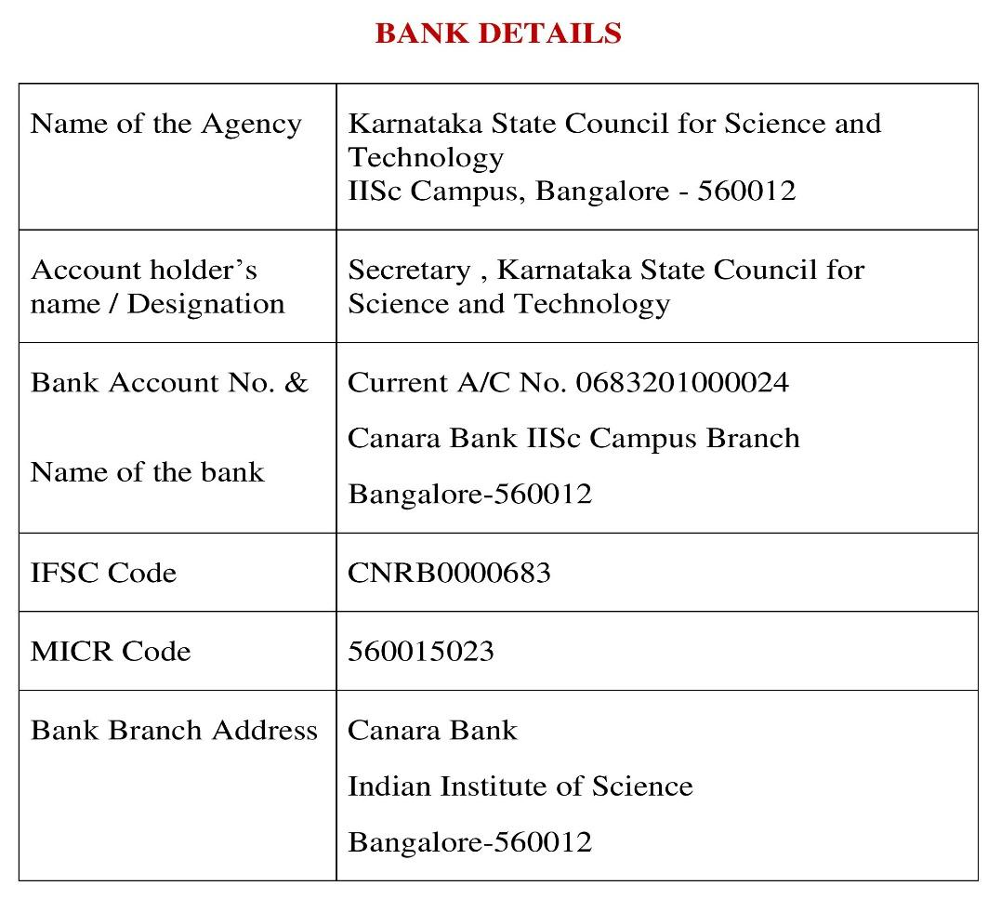
Note: For finance related queries, please contact KSCST accounts section: 080 – 23341652, 23348849 during office hours between 3.00 pm to 5 pm, email: finance@kscst.org.in with a copy to spp@kscst.org.in

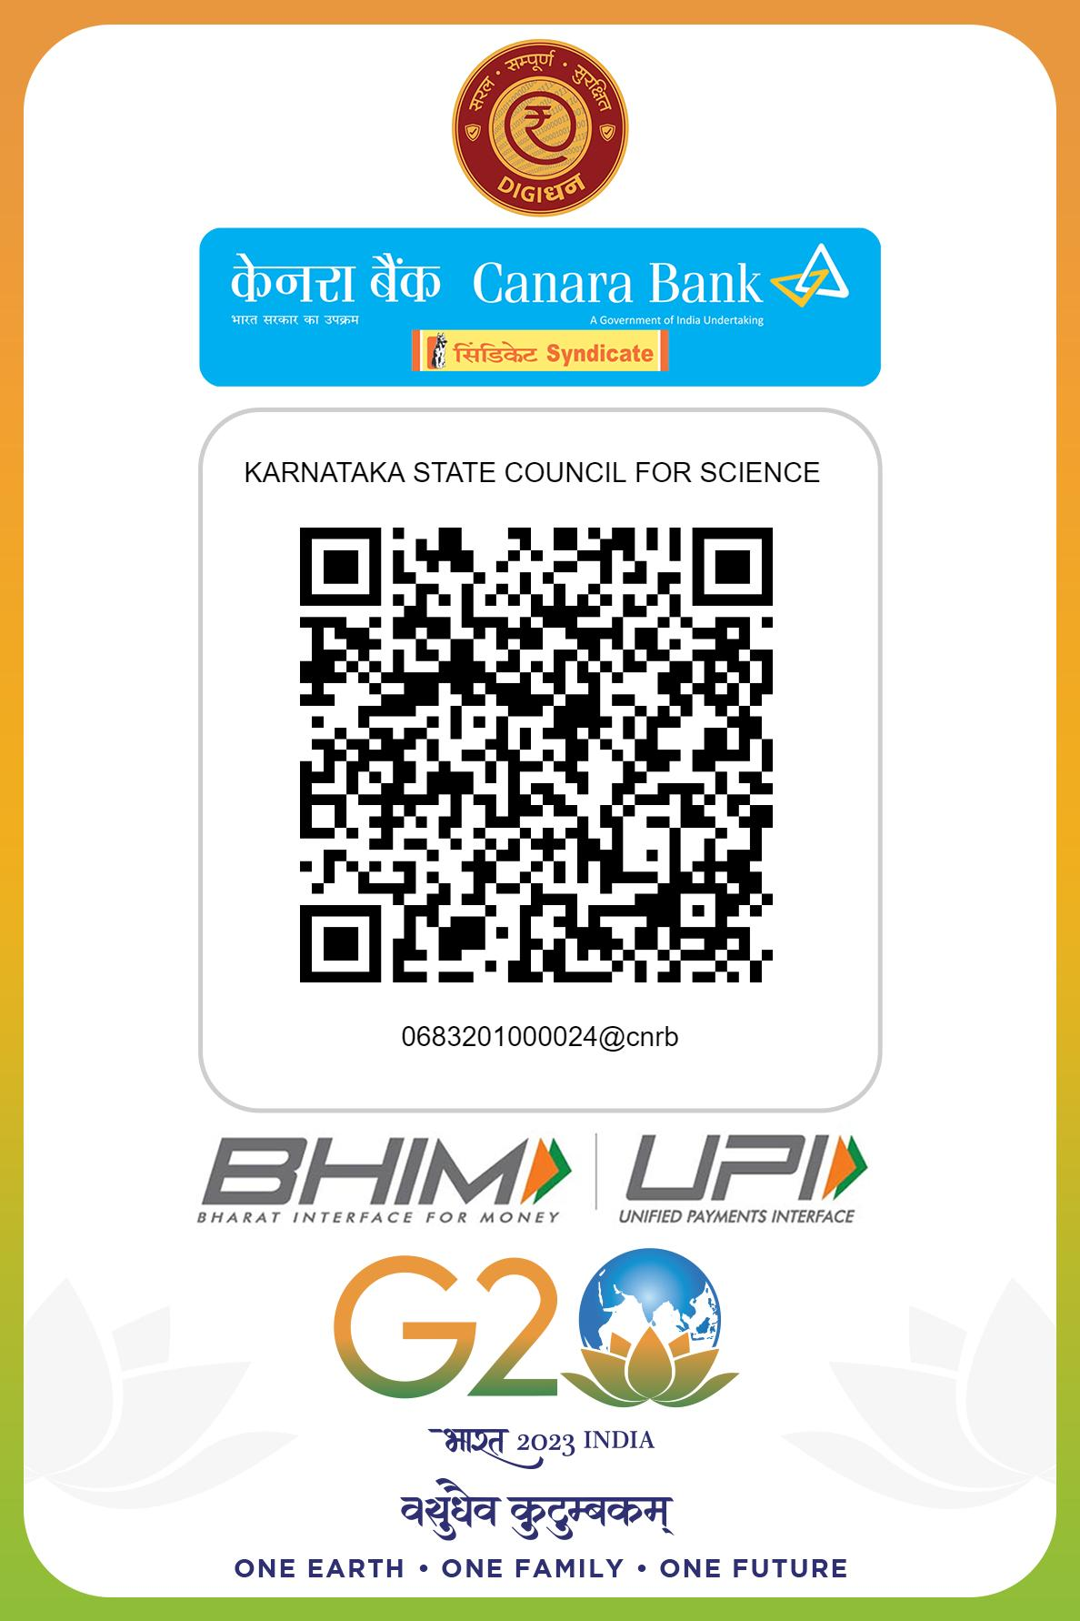
Note: For finance related queries, please contact KSCST accounts section: 080 – 23341652, 23348849 during office hours between 3.00 pm to 5 pm, email: finance@kscst.org.in with a copy to spp@kscst.org.in

